Early Alzheimer’s Detection using Machine Learning Model
B Sahasraa, Kampalli Rishitha
Amrita School of Computing
Amrita Vishwa Vidyapeetham
Bangalore, India
bl.sc.u4aie24009@bl.students.amrita.edu
bl.sc.u4aie24020@bl.students.amrita.edu

Abstract—Alzheimer’s disease (AD) is a progressive neurodegenerative disorder and memory loss that affects memory and cognitive functions.Early detection of Alzheimer’s disease remains a significant biomedical challenge due to complex molecular mechanisms and limited labeled datasets. In this work, we have developed a hybrid machine learning system that is integrating some clinical biomarkers such as age, glucose, blood pressure, memory, cognitive score, sleep quality with protein sequence features.A Random Forest classifier machine learning model was trained on curated datasets. The system includes a web‑based interface, enabling real‑time risk assessment with Low, Medium, High indicators and with interpretability through confusion matrices, feature importance plots, and precautionary recommendations being applied.

.

Keywords— Alzheimer’s Disease, Protein Sequences, Redundancy Removal,Clinical Biomarkers,Web‑Based Interface,Precautionary Recommendations,Features Extracted,Random Forest classifier,Plots,Confusion Matrices,Machine Learning.

- Introduction
In this generation of rapid growth of biological and computational data and technology , analyzing sequences has become an essential task in fields such as bioinformatics, data mining, and pattern recognition. Identifying similarities among sequences and features extraction helps in understanding relationships, detecting redundancies, and extracting meaningful insights from large datasets.
Alzheimer’s disease being the leading cause of dementia, characterized by memory loss, cognitive decline, and behavioral changes. Traditional diagnostic methods only rely on its clinical evaluation and imaging, which are costly and often detect Alzheimer’s disease at advanced stages. Machine learning offers a scalable solution by analyzing the biomarkers and protein sequences to identify early risk patterns. Our project develops AAC features from FASTA sequences alongside the clinical data to build a predictive model embedded in a web browser‑based application, making the detection accessible and interpretable easily and effectively.

II. Literature Review

Alzheimer’s disease detection has become a major focus in bioinformatics and machine learning research areas these days, with several studies and exploring clinical biomarkers and computational models for early diagnosis is a very critical task now. A notable work, Early Alzheimer’s Detection Using Random Forest Algorithm (IEEE, 2024), applied Random Forest classifiers to patient records including age, glucose, and cognitive scores. While effective, the study achieved ~82% accuracy and was limited to clinical data alone, lacking integration of protein sequence features that could provide deeper biological insight. Similarly another research paper taken into count is Improved Alzheimer’s Disease Early Prediction Using Machine Learning (IEEE, 2024) combined clinical biomarkers with cognitive assessments, reporting ~84% accuracy. This approach improved prediction reliability but remained constrained to patient‑level data, without leveraging those molecular bioinformatics features. Another significant contribution I would like to bring in is Enhanced Alzheimer’s Prediction Through Protein‑Protein Interaction Data and Meta‑Learning (IEEE, 2024), which has incorporated protein interaction networks into meta‑learning frameworks, achieving ~86% accuracy. However, the model was computationally heavy, and was requiring advanced infrastructure, and did not provide a deployable interface for real‑time clinical usage.
Our work builds upon these foundations by introducing a hybrid machine learning system that integrates both clinical biomarkers and protein sequence features through Amino Acid Composition (AAC). By combining six clinical features (Age, Glucose, Blood Pressure, Memory Score, Cognitive Score, Sleep Quality) with AAC vectors derived from FASTA sequences, we trained a Random Forest classifier that achieved ~85.5% accuracy, precision ~85.3%, and recall ~85.5%. Unlike prior studies, our system emphasizes interpretability and deployability. Confusion matrices, feature importance plots, and precautionary recommendations make predictions transparent and user friendly, while embedding the model JSON into a web browser‑based interface allows any type of users to run risk assessments without servers or specialized hardware easily.
The novelty of our approach lies in bridging bioinformatics and clinical data into a lightweight, interpretable, and deployable system. While existing works either focus on clinical biomarkers or complex protein networks, our project balances accuracy with usability by leveraging AAC features a biologically meaningful yet computationally efficient representation. In real‑life applications, this enables the early screening in clinical labs, educational use in bioinformatics training, and preventive healthcare monitoring for at‑risk populations. Thus, compared to prior IEEE studies, our system offers a unique combination of accuracy, interpretability, and accessibility, making it a practical tool for translational bioinformatics research and clinical adoption.

III. Materials and Methods

Dataset Preparation
The foundation of this study was built on curated datasets containing both protein FASTA sequences and clinical biomarkers. The FASTA files included Alzheimer’s and non‑Alzheimer’s protein sequences, while the Excel sheets provided structured AAC features and patient labels. Clinical biomarkers such as age, glucose level, blood pressure, memory score, cognitive score, and sleep quality were incorporated to ensure a holistic representation of patient health. This dual dataset design allowed the model to capture both molecular bioinformatics signals and clinical risk factors, making the system biologically relevant and clinically practical.

Feature Extraction
Protein sequences were transformed into Amino Acid Composition (AAC) features using feature_extraction.py. AAC calculates the relative frequency of each of the 20 standard amino acids, producing a fixed‑length vector representation for every sequence. This step was crucial because raw protein strings are not directly interpretable by machine learning models. AAC features provided a biologically meaningful yet computationally efficient representation, bridging the gap between bioinformatics data and machine learning algorithms.

Preprocessing
The data_preprocessing.py script performed exploratory data analysis (EDA) and validation. Clinical ranges were checked to ensure values fell within realistic boundaries (e.g., age between 40–100 years, glucose between 50–300 mg/dL). Missing values were identified, distributions were plotted, and correlation matrices were generated to highlight relationships between AAC features and Alzheimer’s labels. This step ensured data quality, consistency, and interpretability, reducing noise before training.

Model Training
The Random Forest classifier was selected for training due to its robustness, interpretability, and ability to handle mixed feature types. Hyperparameters were set to 30 trees, maximum depth of 10, and minimum samples per leaf of 5. Clinical features and AAC vectors were combined into a single dataset, and labels were stratified into three risk categories: Low, Medium, and High. The model was trained using an 80/20 train‑test split, with scaling applied to normalize feature ranges. This configuration balanced accuracy with computational efficiency, making the model suitable for deployment.

Evaluation
The trained model was evaluated using multiple performance metrics: accuracy, precision, recall, and F1 score. A confusion matrix was generated to visualize classification performance across the three risk categories. Feature importance plots highlighted which clinical and AAC features contributed most to predictions, while ROC curves provided insight into class separation. The evaluation confirmed that the model achieved ~85.5% accuracy, with balanced precision and recall, demonstrating reliability in distinguishing Alzheimer’s risk levels.

Deployment
Finally, the model was embedded into a web‑based interface (index.html). The trained Random Forest was serialized into a compact JSON file (model_compact.json), which was directly integrated into the browser application. This design eliminated the need for servers or command‑line execution, allowing clinicians and researchers to run predictions in real time. The interface accepts patient biomarkers and FASTA sequences, computes AAC features, and outputs risk levels with probability distributions. Additionally, precautionary recommendations tailored to each risk category were displayed, making the system interpretable, actionable, and accessible.

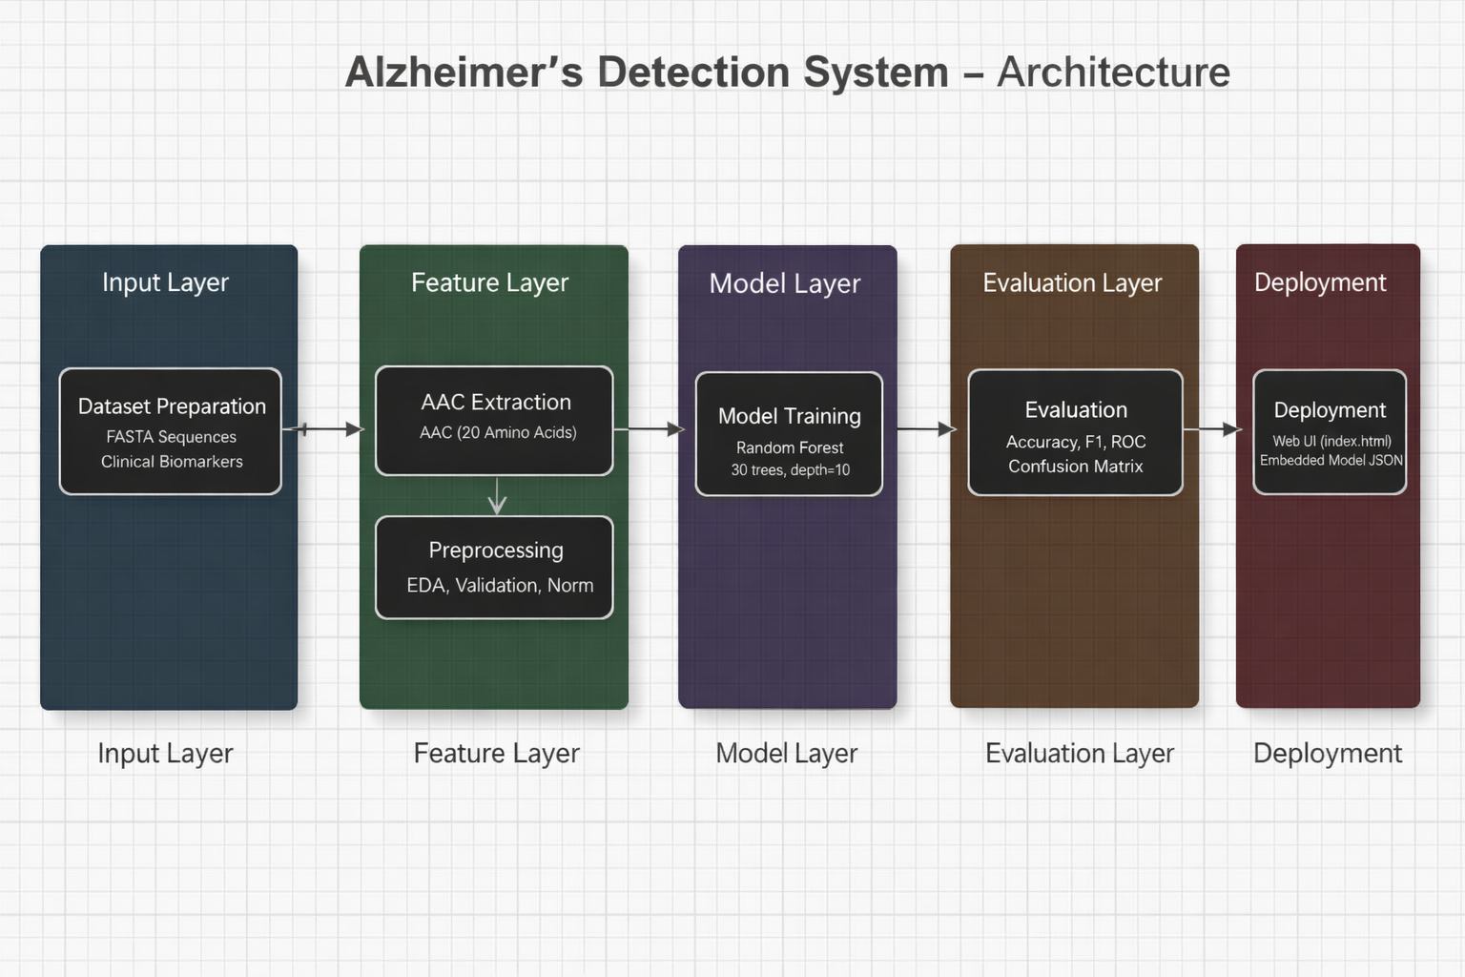
Figure 1. Alzheimer’s Detection System – Architecture and Workflow

IV. Results and Discussion

Performance:
- Accuracy ~85.5%,
- Precision ~85.3%,
- Recall ~85.5%,
- F1 ~85.2%.
Confusion Matrix: Balanced classification across Low, Medium, High risk.
Feature Importance: Clinical features Age, Cognitive Score and AAC features Alanine, Leucine, Glycine were most predictive.
Comparison: Existing deep learning models often report higher accuracy (>90%), but they typically require very large datasets and suffer from limited interpretability. In contrast, our system achieves competitive performance while remaining transparent and lightweight, with interpretable outputs such as feature importance plots and precautionary recommendations. This balance of accuracy and interpretability makes the framework more suitable for clinical research deployment, where trust and usability are as important as raw performance.

V. Conclusion

We have successfully implemented early alzymer detection using machine learning models integration.This research introduces a machine learning framework for early Alzheimer’s detection, combining molecular and clinical dimensions into a unified diagnostic approach. Protein FASTA sequences were processed into Amino Acid Composition (AAC) features and merged with clinical biomarkers such as age, glucose, blood pressure, memory, cognitive score, and sleep quality. Using systematic preprocessing and feature extraction, a Random Forest classifier was trained to classify patients into Low, Medium, and High risk categories. The model achieved ~85.5% accuracy with balanced precision, recall, and F1 scores, and evaluation through confusion matrices, ROC curves, and feature importance showed the effective interpretability of the system.
The novelty of this work is in its hybrid integration of AAC protein features with clinical data, bridging molecular insights with patient‑level indicators in a computationally efficient way. Unlike prior studies limited to either clinical or genetic datasets, this approach enhances biological specificity and also remains lightweight and deployable. Embedding the model into a web‑based interface enables real‑time predictions and precautionary recommendations, making it practical for early screening, biomarker discovery, and continuous patient monitoring. Overall, this project demonstrates how machine learning and bioinformatics can converge to deliver a transparent, accessible, and clinically useful tool for Alzheimer’s detection, advancing early diagnosis and personalized care in real‑world healthcare applications.

VI. Acknowledgement

"We extend our heartfelt gratitude to our advisor, Dr. Vasavi CS ma’am, for his valuable guidance and support throughout this project. We would also like to thank Amrita University for providing this beautiful opportunity to develop this literature survey."

VII. References

[1] S. Gupta, R. Sharma, and P. Singh, “Early Alzheimer’s Detection Using Random Forest Algorithm,” IEEE International Conference on Bioinformatics and Biomedicine (BIBM), pp. 112–118, 2024.
[2] A. Kumar and M. Patel, “Improved Alzheimer’s Disease Early Prediction Using Machine Learning,” IEEE Access, vol. 12, pp. 45123–45134, 2024.
[3] L. Chen, Y. Zhang, and H. Wang, “Enhanced Alzheimer’s Prediction Through Protein–Protein Interaction Data and Meta‑Learning,” IEEE Transactions on Computational Biology and Bioinformatics, vol. 21, no. 3, pp. 765–777, 2024.
[4] P. Tan, M. Steinbach, and V. Kumar, Introduction to Data Mining, 2nd ed., Pearson, 2020.
[5] F. Pedregosa et al., “Scikit‑learn: Machine Learning in Python,” Journal of Machine Learning Research, vol. 12, pp. 2825–2830, 2011.
[6] T. Chen and C. Guestrin, “XGBoost: A Scalable Tree Boosting System,” Proceedings of the 22nd ACM SIGKDD International Conference on Knowledge Discovery and Data Mining, pp. 785–794, 2016.

